Unit testing : Using Moq
https://www.youtube.com/watch?v=SHAKzgYtu9E

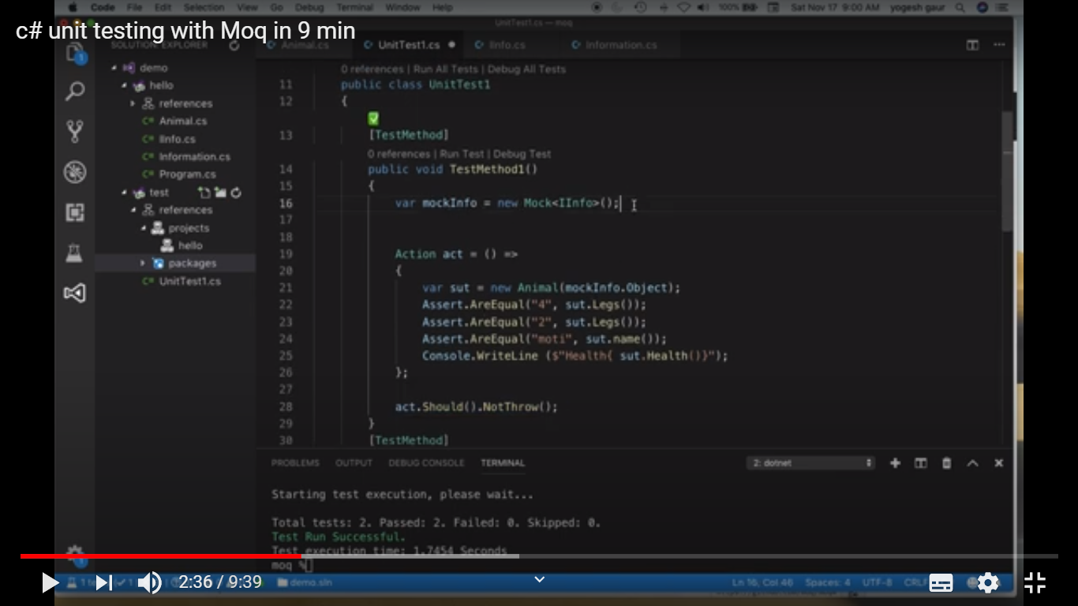

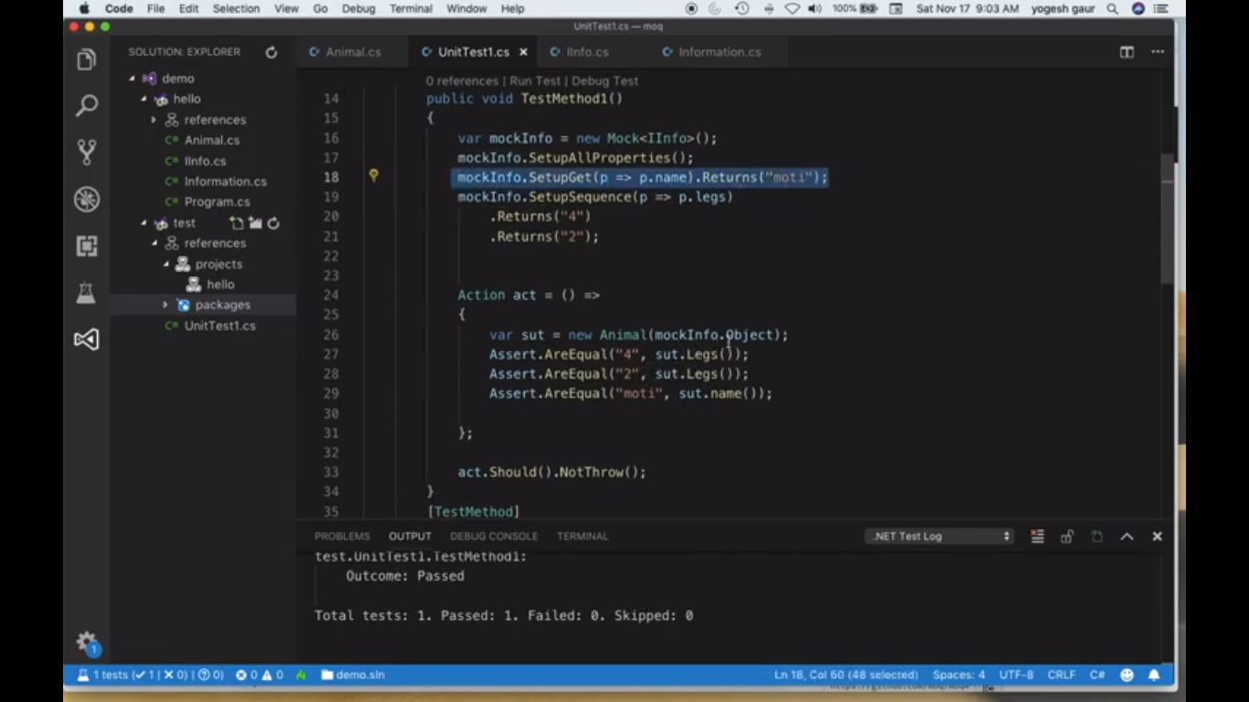

Mock for protected method , need to make them Virtual
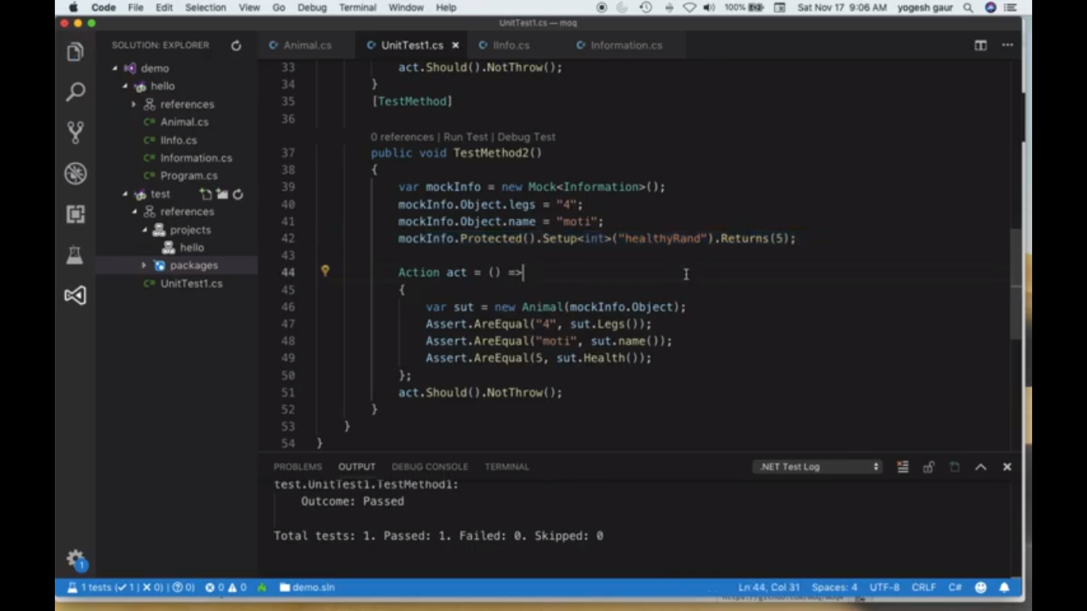

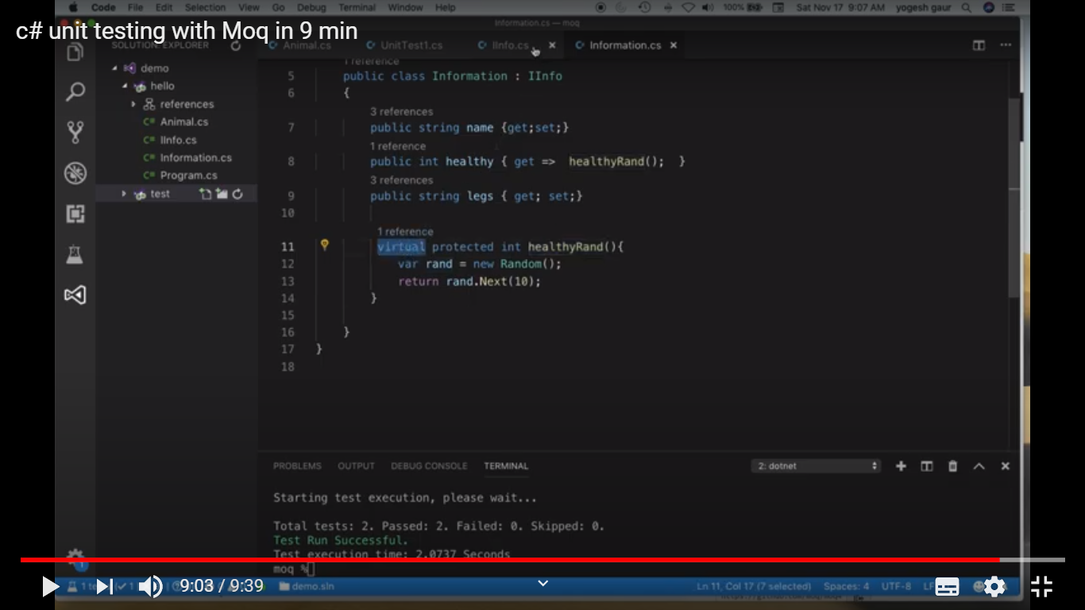

2) https://www.youtube.com/watch?v=9ZvDBSQa_so

Getting started with Mocking using Moq in .NET (Core, Framework, Standard) : 22 mins

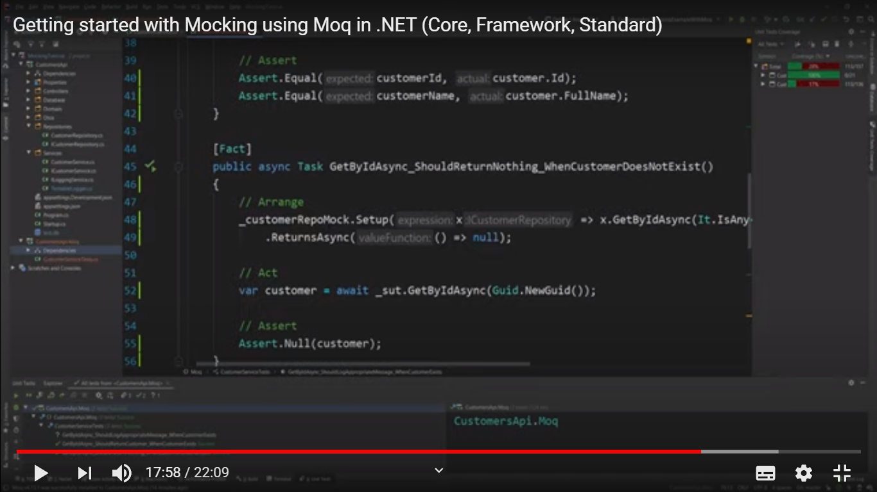

https://stackoverflow.com/questions/11830911/test-if-save-method-is-hit-in-unit-test
[TestMethod()]
public void Test_SaveCalledWhenCreateCalled()
{
// Arrange
// First, instead of creating an instance of your test class, you create a mock repository.
// In fact, you don't need to write any code, the mocking framework handles it.
var mockRepository = new Mock<IUserManagementRepository>();
// and pass the mock repository (which implements the IUserManagementRepository) to your controller
UserController controller = new UserController(mockRepository);

// Act
ActionResult actionResult = controller.Create(user);

// Assert
// see how easy it is to do with a mocking framework:
mockRepository.Verify(rep => rep.Save(), Times.AtLeastOnce());
}

